GOVERNMENT DEGREE COLLEGE, TADIPATRI,
ANANTAPUR DISTRICT, ANDHRA PRADESH

ANNUAL QUALITY ASSURANCE REPORT (AQAR) 2017-18

Submitted to
NATIONAL ASSESMENT AND ACCREDITATION COUNCIL (NAAC)
BANGALORE

The Annual Quality Assurance Report (AQAR) of the IQAC

Part – A
- Details of the Institution
  - Name of the Institution GOVERNMENT DEGREE COLLEGE, Tadipatri
  - Address Line 1 Near Auto Nagar
Address Line 2 Tadipatri
City/Town ANANTAPUR (Dist.,)
State ANDHRA PRADESH
Pin Code 515411
Institution e-mail address jkc.tadipatri@gmail.com
Contact Nos. 08554-222325 & 9866287496
Head of the Institution: Sri A. Narayana Swamy
Tel. No. with STD Code: 08554-222325
9949018368
Mobile:
9441983952
Name of the IQAC Co-ordinator: Sri H. Siva Sankar Mobile:
iqac.gdctadipatri@gmail.com
IQAC e-mail address:

APCOGN13270
1.3 NAAC Track ID (For ex. MHCOGN 18879)

NAAC/WH/Cert-A&A/2007/197 dt 24-4-2007
1.4 NAAC Executive Committee No. & Date:
(For Example EC/32/A&A/143 dated 3-5-2004.
This EC no. is available in the right corner- bottom of your institution’s Accreditation Certificate)

www.gdctadipatri.ac.in
1.5 Website address:

http://www.gdctadipatri.ac.in/facilities.php?id=6

Web-link of the AQAR:
For ex. http://www.ladykeanecollege.edu.in/AQAR2012-13.doc 1.6 Accreditation Details
Sl. No. | Cycle | Grade | CGPA | Year of  Accreditatio n | Validity Period
1 | 1st Cycle | B⁺ | 76.00 | 2007 | 5Years
2 | 2nd Cycle
3 | 3rd Cycle
4 | 4th Cycle

18.06.2011

1.7 Date of Establishment of IQAC: DD/MM/YYYY

2017-18
1.8 AQAR for the year (for example 2010-11)

1.9 Details of the previous year’s AQAR submitted to NAAC after the latest Assessment and Accreditation by NAAC ((for example AQAR 2010-11submitted to NAAC on 12-10-2011)
i. AQAR _2013-14_submitted to NAAC on 26/12/2018 (DD/MM/YYYY) ii. AQAR _2013-14_submitted to NAAC on 26/12/2018 (DD/MM/YYYY) iii. AQAR _2014-15_submitted to NAAC on 26/12/2018 (DD/MM/YYYY) iv. AQAR _2015-16_submitted to NAAC on 26/12/2018 (DD/MM/YYYY) v. AQAR _2016-17_submitted to NAAC on 26/12/2018 (DD/MM/YYYY)

1.10 Institutional Status
University State  Central Deemed Private

Affiliated College Yes  No
Constituent College Yes No

Autonomous college of UGC Yes No
Regulatory Agency approved Institution Yes No
(eg. AICTE, BCI, MCI, PCI, NCI)
Type of Institution Co-education  Men Women

Urban Rural  Tribal

Financial Status Grant-in-aid UGC 2(f)  UGC 12B 

Grant-in-aid + Self Financing Totally Self-financing

1.11 Type of Faculty/Programme

Arts  Science  Commerce  Law PEI (Phys Edu)

TEI (Edu) Engineering Health Science Management

Others (Specify)
SRI KRISHNADEVARAYA UNIVERSITY, ANANTAPUR
1.12 Name of the Affiliating University (for the Colleges)

1.13 Special status conferred by Central/ State Government-- UGC/CSIR/DST/DBT/ICMR etc

Autonomy by State/Central Govt. / University

University with Potential for Excellence UGC-CPE

UGC-CE
DST Star Scheme

DST-
FIST
UGC-Special Assistance Programme

 | Any other (Specify | )
UGC-Innovative PG programmes

UGC-COP Programmes
- IQAC Composition and Activities
4
1
  - No. of Teachers
  - No. of Administrative/Technical staff
  - No. of students ⁶
  - No. of Management representatives 1
  - No. of Alumni 1
- 6 No. of any other stakeholder and community representatives ⁴
  - No. of Employers/ Industrialists 3

  - No. of other External Experts 2
  - Total No. of members ₂₂
2.10 No. of IQAC meetings held |  | 2
3
  - No. of meetings with various stakeholders: No. Faculty ¹

0
1 | Alumni | 1
Non-Teaching Staff Students Others

  - Has IQAC received any funding from UGC during the year? Yes No 
If yes, mention the amount

2.13Seminars and Conferences (only quality related)
    - No. of Seminars/Conferences/ Workshops/Symposia organized by the IQAC
Total Nos. 2 International National State

Institution Level
• | Faculty Development Programme on “Teaching – learning audit and student’s feed back systems” held on 21th July 2017.
• | Faculty Development Programme on “Enhancement of Creative Potential in Teachers” held on 8th February 2018.
    - Themes

  - Significant Activities and contributions made by IQAC
      - The annual plan of the college has been prepared in consultation of various Teaching Departments and implemented.
      - Periodical meetings with staff members are initiated to formulate the plan of action. The implementation of action plans are reviewed in the subsequent meetings.
      - Intensive Remedial coaching has been given to academically poor students.
      - The curricular, co-curricular and extra-curricular activities have been monitored.

      - Audit to monitor and ensure the quality of student’s activities, department activities and staff members for periodic assessment for timely, efficient and progressive

performance of academic task.
      - Sensitizing students to ecological and environmental issues

  - Plan of Action by IQAC/Outcome
The plan of action chalked out by the IQAC in the beginning of the year towards quality enhancement and the outcome achieved by the end of the year
Plan of Action |  | Achievements
 | ODD SEMESTER
IQAC Annual Strategic Meet |  | Briefed about the Annual Action Plan
Faculty Development Programme |  | Reinforced the Institutional Culture and strengthen various teaching skills sets, 2 FDPs were conducted in the Institution.
Orientation for all the Students | Oriented about the Institution, academic, Examinations, Co-curricular and Extracurricular system
Orientation for Parents | Oriented about the Institution, academic, Examination, Co-curricular and Extracurricular system and the role of parents in collaborating with the Institution
General Staff Meetings | Arranged to deliberate, appraise and draw consensus on result analysis and develop action plans strategically.
Increase Industry-Academia collaborations | A number of MOU’s were signed up with industries and professional bodies.
Reach out and make contribution to the society and improvised people | Many number of outreach extension activities were conducted
EVEN SEMESTER
To communicate about all activities of the College. | To discuss, deliberate and decide on various academic policies and programmes.
Conduct of Remedial Classes | Remedial classes for improvement of slow learners.
To make use of MANA TV programs more effectively | Students regularly attending MANA TV programmes as per the schedule
Proposed to enlighten women students on personality development, health and  hygiene | Women Empowerment Cell conducted programmes on health and hygiene along with personality development programmes
Coaching for PG entrances during the academic year | Coaching is given for PGCET exams
* Attach the Academic Calendar of the year as Annexure.
2.15 Whether the AQAR was placed in statutory body Yes No


 | Syndicate
Management Any other body
Provide the details of the action taken
The plan of action chalked out by the IQAC in the beginning of the year towards quality enhancement and the outcome achieved by the end of the year *
AQAR was placed before staff council, after active discussions incorporated valid suggestions. Staff council has approved final report and accorded permission to forward the AQAR to
NAAC.

Part – B
Criterion – I

- Curricular Aspects
  - Details about Academic Programmes
Level of the Programme | Number of existing  Programmes | Number of programmes  added during the year | Number of self-financing programmes | Number of value added / Career  Oriented programmes
PhD
PG
UG | 04 |  | 02
PG Diploma
Advanced Diploma
Diploma
Certificate
Others
Total | 04 |  | 02

Interdisciplinary
Innovative

  - (i) Flexibility of the Curriculum: Core (ii) Pattern of programmes:
Pattern | Number of programmes
Semester | 
Trimester
Annual

  - Feedback from stakeholders*


 | Students | 

Alumni Parents Employers (On all aspects)
Mode of feedback : Online Manual  Co-operating schools (for PEI)
*Please provide an analysis of the feedback in the Annexure

  - Whether there is any revision/update of regulation or syllabi, if yes, mention their salient aspects.
Added value added programmes and certificate programmes

  - Any new Department/Centre introduced during the year. If yes, give details.
No

Criterion – II 2. Teaching, Learning and Evaluation
Total | Asst. Professors |  | Associ Profess | ate  ors | Professors | Others
10 | 10
 |  |  | 02
2.1 Total No. of
permanent faculty
2.2 No. of permanent faculty with Ph.D.
Asst.  Professors |  | Associate Professors |  | Professors |  | Others |  | Total
R | V | R | V | R | V | R | V | R | V
 | 9 |  |  |  |  |  |  |  | 9
2.3 No. of Faculty Positions
Recruited (R) and Vacant (V) during the year

2.4 No. of Guest and Visiting faculty and Temporary faculty
03 |  |  |  | 05

2.5 Faculty participation in conferences and symposia:

No. of Faculty | International level | National level | State level
Attended |  | 10
Presented |  | 20
Resource Persons

2.6 Innovative processes adopted by the institution in Teaching and Learning:
Establishing the semester curricular plan for every subject well before the commencement of each semester along with the course hand outs which are made available to all students on the start of the academic year
Teacher’s study materials [soft copy -power point/PDF presentation] are shared with students
Teaching faculty and students are encouraged to use latest technology such as LCD, internet, etc., in the teaching learning process

Institution conducts remedial classes and diagnostic tests for slow learners based on that it adopts teaching strategies to improve the level of learning.

For advance learners, the institution encourag es them to take part in student study projects and presentation of papers at various levels.

229
2.7 Total No. of actual teaching days during this academic year

NA
2.8 Examination/ Evaluation Reforms initiated by the Institution (for example: Open Book Examination, Bar Coding,
Double Valuation, Photocopy, Online Multiple Choice Questions)

03 BOS
2.9 No. of faculty members involved in curriculum
Restructuring / revision/ syllabus development
as member of Board of Study/Faculty/Curriculum Development workshop

78
2.10 Average percentage of attendance of students

2.11 Course/Programme wise distribution of pass percentage:

Title of the  Programme | Total no. of students appeared |  |  | Division
 |  | Distinction  % | I % | II % | III % | Pass %
B.Sc., | 19 | 3 | 2 | 3 | 5 | 68%
B.A., | 5 |  | 1 | 4 |  | 100%
B. Com., | 27 | 2 | 2 | 5 | 6 | 56%
2.12 How does IQAC Contribute/Monitor/Evaluate the Teaching & Learning processes:

Preparing academic calendar at the beginning of every semester that consists of departmental activities like Seminars, workshops, guest lectures, internal tests, class committee meetings, Field or industrial visits and practical examinations, etc., for
effective planning of teaching learning process.
Apart from the prescribed syllabus, value additions are also provided by the faculty members to widen their knowledge in every subject
Special attention for the slow learners is given through mentoring, coaching classes after the working hours.

Reviewing the progress of syllabus completion, performance of the students, other activities in the department level meetings.
Reviewing every course log books (both theory and laboratory) by the Lecturer Incharge by the Principal once in a month to monitor the effective completion of the courses.

2.13 Initiatives undertaken towards faculty development
Faculty / Staff Development Programmes | Number of faculty benefitted
Refresher courses | 02
UGC – Faculty Improvement Programme
HRD programmes
Orientation programmes
Faculty exchange programme
Staff training conducted by the university
Staff training conducted by other institutions
Summer / Winter schools, Workshops, etc.
Others: Training in Human Values and professional ethics | 01
2.14 Details of Administrative and Technical staff
Category | Number of  Permanent  Employees | Number of  Vacant  Positions | Number of permanent  positions filled during the Year | Number of  positions filled temporarily
Administrative Staff | 05 | 07
Technical Staff
Criterion – III
- Research, Consultancy and Extension
  - Initiatives of the IQAC in Sensitizing/Promoting Research Climate in the institution
The college motivates the teachers for participating in research by providing them necessary facilities, travel grants and leave for attending National/International level seminar, etc. The students are also encouraged to participate in such activities.

  - Details regarding major projects
 | Completed | Ongoing | Sanctioned | Submitted
Number
Outlay in Rs. Lakhs

  - Details regarding minor projects
 | Completed | Ongoing | Sanctioned | Submitted
Number
Outlay in Rs. Lakhs

  - Details on research publications
 | International | National | Others
Peer Review Journals
Non-Peer Review Journals
e-Journals
Conference proceedings |  | 01

  - Details on Impact factor of publications:
Range Average h-index Nos. in SCOPUS

  - Research funds sanctioned and received from various funding agencies, industry and other organisations
Nature of the Project | Duration Year | Name of the funding Agency | Total grant sanctioned | Received
Major projects
Minor Projects
Interdisciplinary Projects
Industry sponsored
Projects
sponsored by the
University/
College
Students research projects (other than compulsory by the University) | 2017-18 | Alumni  Association &  Staff | 3000/- | 3000/-
Any
other(Specify)
Total | 03 |  | 3000/- | 3000/-

  - No. of books published i) With ISBN No. Chapters in Edited Books

ii) Without ISBN No.
  - No. of University Departments receiving funds from
UGC-SAP CAS DST-FIST
DBT Scheme/funds
DPE

  - For colleges Autonomy CPE DBT Star Scheme
Any Other (specify)
INSPIRE CE
  - Revenue generated through consultancy

  - No. of conferences organized by the Institution
Level | International | National | State | University | College
Number |  |  |  |  | 4
Sponsoring agencies |  |  |  |  | Staff

02
  - No. of faculty served as experts, chairpersons or resource persons
  - No. of collaborations International National Any other
04
  - No. of linkages created during this year
  - Total budget for research for current year in lakhs :
From Funding agency From Management of University/College
Total
  - No. of patents received this year
Type of Patent |  | Number
National | Applied
 | Granted
International | Applied
 | Granted
Commercialised | Applied
 | Granted

  - No. of research awards/ recognitions received by faculty and research fellows of the institute in the year

Total | International | National | State | University | Dist | College

01
  - No. of faculty from the Institution who are Ph. D. Guides

01
and students registered under them

  - No. of Ph.D. awarded by faculty from the Institution

  - No. of Research scholars receiving the Fellowships (Newly enrolled + existing ones)
 | SRF |  | Project Fellows Any other
JRF
  - No. of students Participated in NSS events:
University level 55 State level
National level International level
  - No. of students participated in NCC events:
University level State level
National level International level
  - No. of Awards won in NSS:
University level State level National level International level
  - No. of Awards won in NCC:
University level State level
National level International level
  - No. of Extension activities organized
13
University forum College forum
NCC NSS 9 Any other 12
  - Major Activities during the year in the sphere of extension activities and Institutional Social Responsibility
Environment and Water Conservation
Ban of Plastic in Society
Swachhata Abhiyan
National Youth day
International Women Day
National Unity Day
Women Health & Hygiene
Other national and International Days of Importance
ODF, Awareness on Cashless transactions
Domalapai Dandayaatra

Criterion – IV
- Infrastructure and Learning Resources
  - Details of increase in infrastructure facilities:
Facilities | Existing | Newly  created | Source of Fund | Total
Campus area | 10.0Acres |  |  | 10. 0Acres
Class rooms | 11 |  |  | 11
Laboratories | 06 |  |  | 06
Seminar Halls | 01 |  |  | 01
No. of important equipments purchased (≥ 1-0 lakh) during the current year.
Value of the equipment purchased during the year (Rs. in Lakhs)
Others

  - Computerization of administration and library

Partial office automation done and Automation of Library is under planning. CCTV cameras are also installed in the premises.

  - Library services:
 | Existing |  | Newly added |  |  | Total
 | No. | Value | No. | Value | No. | Value
Text Books | 14897 | 1426766/- | 907 | 1,11,000/- | 15804 | 1537766/-
Reference Books | 1050 | 98690/- | - | - | 1050 | 98690/-
e-Books | - | - | - | - | - | -
Journals | 4 | 9235/- | - | - | 4 | 9235/-
e-Journals | - | - | - | - | - | -
Digital Database | - | - | - | - | - | -
CD & Video | 50 | 2500/- | - | - | 50 | 2500/-
Others (specify) | 29 | 21696/- | - | - | 29 | 21696/-
Magazines | 16 | 10477/- | 16 | 10477/- | 32 | 20954/-
News Papers |  |  | 2 | 3600/- | 2 | 3600/-

  - Technology up gradation (overall)
 | Total Computers | Computer Labs | Internet | Browsing Centres | Computer Centres | Office | Departments | Others
Existing | 24 | 2 | Available  to all Depts |  |  | 4  Computers in use | 7 Computers in use | 1
Added
Total | 24 | 2 | Available  to all Depts |  |  | 4  Computers in use | 7 Computers in use | 1

  - Computer, Internet access, training to teachers and students and any other programme for technology upgradation (Networking, e-Governance etc.)

Access to internet and computer facilities to teachers and students of the Institute provided.

  - Amount spent on maintenance in lakhs :
_
    - ICT

57347/-
    - Campus Infrastructure and facilities

_
    - Equipments

24510/-
    - Others

81857/-

Total :

Criterion – V 5. Student Support and Progression
5.1 Contribution of IQAC in enhancing awareness about Student Support Services
• | Various Committees and Cells cater to student support and progression.
• | Prospectus & Student Handbook gives guidelines for various student support facilities the institution provides.
• | Orientation Programme is conducted at the beginning of the Academic year
• | Class In-charges facilitate student support in curricular and co-curricular activities
• | Notices are sent to the classes and also displayed on the notice boards
• | SMS is sent to the ward’s parent in case of absenteeism or shortage of attendance
• | Arrangement of industrial visit to enhance practical knowledge done.
• | Comprehensive Continuous Internal Assessment done through projects, assignments.
• | Students are informed and reminded at regular intervals through circulars, Whatsapp groups and SMS. Announcements and reminders are also given through class mentors, counsellors and class representatives about student support service.

5.2 Efforts made by the institution for tracking the progression
• | Class counselling services are there to assess the overall development of the students
• | Student’s progressions are tracked through scrutiny of their performance records by class mentors and counsellors.
• | Remedial and special classes in addition to personal counselling are conducted
5.3 (a) Total Number of students
UG | PG | Ph. D. | Others
247 | 0 | 0 | 0

- No. of students outside the state
- No. of international students
No | %
206 | 83.40%
No | %
41 | 16.59%
Men Women

Women

 |  | Last Year 2016-17 |  |  |  |  | This Year 2017-18
Gene ral | SC | ST | OBC | Physically  Challenged  &  Others | Total | Gen  eral | SC | ST | OBC | Physic ally  Challe nged | Total
14 | 91 | 6 | 120 | 0 | 231 | 14 | 91 | 5 | 137 | 0 | 247

Demand ratio 1: 25 Dropout 4%
  - Details of student support mechanism for coaching for competitive examinations (If any)
• | Coaching in the form of quantitative techniques and logical reasoning and current affairs are included in the curriculum schedule to help students to enhance their skills for competitive examinations.
• | The foundation courses prescribed by the S.K.University, Anantapur like  Analytical Skills, Entrepreneurship development, Leadership skills, Communication and Soft skills are very much useful for the preparation of competitive examinations.

150
No. of students beneficiaries
  - No. of students qualified in these examinations
NET SET/SLET GATE CAT
IAS/IPS etc State PSC UPSC Others
  - Details of student counselling and career guidance
The placement co-ordinator arranges regular career guidance lectures by industry experts.

Each student has counsellor for guidance and mentoring is available

No. of students benefitted: 43

  - Details of campus placement
 | On campus |  | Off Campus
Number of  Organizations  Visited | Number of  Students  Participated | Number of Students Placed | Number of Students Placed
0 | 0 | 3 | 20

  - Details of gender sensitization programmes
• | Celebration of Women Equality day, Women Teachers day, International  Women’s day
• | Awareness on Women grievance redressal
• | Women Health and hygiene Awareness Programme
  - Students Activities
    - No. of students participated in Sports, Games and other events

State/ University level 17 National level International level

No. of students participated in cultural events

State/ University level National level International level

    - No. of medals /awards won by students in Sports, Games and other events
Sports : State/ University level 2 National level International level

Cultural: State/ University level National level International level 5.10 Scholarships and Financial Support
 | Number of students | Amount
Financial support from institution
Financial support from government | 166 | 2,97,421/-
Financial support from other sources
Number of students who received
International/ National recognitions

  - Student organised / initiatives
Fairs : State/ University level National level International level
Exhibition: State/ University level National level International level

20
  - No. of social initiatives undertaken by the students:

  - Major grievances of students (if any) redressed:
- Need more drinking water facility
- Toilets Repair

Criterion – VI
- Governance, Leadership and Management
  - State the Vision and Mission of the institution
Vision

To impart higher education with knowledge amalgamated with ethnical norms and values which involves academic excellence, spiritual growth, social
commitment and value based leadership.

Mission

To entrust its products with the responsibility of involving themselves in

“Make in India” and mould the Students by tapping their innate potentialities to establish themselves as global citizens with utmost competence, conscience, confident, compassionate and commitment skills. Special concern is shown
towards the socially and economically marginalized rural students.

  - Does the Institution has a management Information System
The College dissipates its information through its websites. A well-established mechanism at the office of the Principal, GDC, Tadipatri ensures that all the necessary information that need to reach students, teachers and non-teaching staff reaches on time. Besides, the individual departments have their own arrangement of dissipating necessary information and notifications to students.

  - Quality improvement strategies adopted by the institution for each of the following:
6.3.1 Curriculum Development
Encourage faculty to attend various Conferences/Seminars organised outside the college which engages the faculty to enhance their subject knowledge, interact with experts from Academia, Industry and Faculty from other institutions. This facilitates the Curriculum development.
Through Guest Lectures / Seminars conducted , the students would be able to know the market trends and requirements for incorporating the relevant content into the curriculum for enhancing the skills and career prospects to the students.

Administering and analysing feedback on curriculum aspects from students and other stakeholders
The college follows the guidelines issued by the Sri Krishnadevaraya University, Anantapur. Faculty are motivated to conduct value added certificate courses with an MoU.

6.3.2 Teaching and Learning
• | Academic calendar is prepared well ahead before the start of the Academic year to know the Academic schedule
• | Infrastructural resources for effective Teaching -Learning is checked before the beginning of the Academic year
• | Semester/ Monthly planner are prepared by the respective departments which include the Student Centric activities like club activities, Seminars / Guest Lectures and industrial visits to be conducted for a course
• | Unit Planners are prepared by the subject lecturers which provide a road map to teach a subject. It includes subject relevant activities, reference books, web references and teaching methodology to be adopted to teach a particular topic.
• | Faculty are instructed to be regular and to be on time to the classes to facilitate for proper teaching -learning to happen
• | Departments are encouraged to conduct bridge courses to fill the gaps if any
• | Innovative and ICT backed teaching methodologies are adopted
• | The Teaching diary help i n evaluating our status of completion of syllabus
• | Remedials & tutorials are conducted for slow learners.

6.3.3 Examination and Evaluation
• | Since the institution is affiliated to Sri Krishnadevaraya University, Anantapur, the Year End Exams are conducted and the same are evaluated by the above cited University. The Marks Memos are also awarded by the University.
• | Regular periodical tests, Assignments and evaluation is done by all concerned faculty members
• | Semester system with Continuous Internal Assessment (CIA) is followed
• | 25 % marks (Internal Assessment) and 75% marks is evaluated by the external assessment
• | The examination system and evaluation procedures are made known to the students by giving the question paper pattern, distribution of marks a nd scheme of valuation

6.3.4 Research and Development
• | Teachers and Students are encouraged to publish papers in journals and conferences.
• | Motivating the faculty to register for M.Phil/Ph.D and apply for Minor Research Projects to UGC
• | Flexible time table and financial assistance to attend and participate in seminars/workshops/conferences etc at the regional /state level.
• | Eminent resource persons are invited to conduct workshops/seminars/guest  lectures on topics of research interest.
• | Fac ulty members with Doctorate degree are encouraged to take up the role of internal guides to their peers pursuing research and publications.
6.3.5 Library, ICT and physical infrastructure / instrumentation
Subscribed Latest magazines, Educational CDs & DVDs, Computer labs with internet facility.
At the beginning of the academic year need- assessment for replacement /up gradation/addition of the existing infrastructure with Library, Labs, ICT and Physical infrastructure is carried out based on the suggestions Heads of the departments, lab technicians and system administrator after reviewing course requirements, computer- student ratio, budget constraints, working condition of the existing equipment and also students’ grievances.

Library Committee, Staff and Students request for Library resources are invited to
upgrade the Library and its resources.

6.3.6 Human Resource Management
•  •  •  • | Staff Feedback given by the students and self appraisal (API) is used to evaluate staff on maintain the standards of Teaching-Learning- Evaluation Training and development programmes for teaching and non-teaching staff are conducted as per the requirement.  Orientation of the newly recruited staff is conducted to help them understand the system in the college  Welfare measures for teaching and non-teaching staff are continued. Employees are given utmost importance and their needs are recognized well.  6.3.7 Faculty and Staff recruitment
6.3.7 Faculty and Staff recruitment

Human Resource planning is done based on the workload in the departments and

vacancy and a schedule is prepared to recruit the guest faculty from qualified and competent members according to the requirement by screening committee.
All eligible candidates are informed to attend interview along with the original certificates.

6.3.8 Industry Interaction / Collaboration
The College encourages the departments to identify industry collaborators for curriculum design and development, certificate courses, Projects, internships, field trips, industrial visits, guest lectures, workshops, seminars, placements,
career guidance etc…

6.3.9 Admission of Students
• | The institution adopts the norms prescribed by the bodies such as APCCE, Sri Krishnadevaraya University, UGC etc. which improves the quality in admission of students.
• | Admission Committee of the college comprising the Principal, Vice - Principal, Heads of the Departments and senior faculty ensures transparent and effective admission process.
• | While admitting the students into the programmes proper measures are adopted to ensure the quality in admission of students.
• | Admissions are made as per the Merit and reservation

Teaching | Yes
Non  teaching | Yes
Students | Scholarships, Bus Pass, Coaching for competitive exams
6.4 Welfare schemes for

- The institution maintains a Health centre by visiting Doctor and a well-trained Nurse for the benefit of staff and students.
- Appropriate arrangements are made to take the staff and students to the nearby hospital whenever advanced medical care is needed.

  - Total corpus fund generated

  - Whether annual financial audit has been done  Yes No
  - Whether Academic and Administrative Audit (AAA) has been done?
Audit Type | External |  | Internal
 | Yes/No | Agency | Yes/No | Authority
Academic | Yes | CCE | No
Administrative | No |  | No

  - Does the University/ Autonomous College declare results within 30 days?
For UG Programmes Yes  No

For PG Programmes Yes No

  - What efforts are made by the University/ Autonomous College for Examination Reforms?
• | The introduction of continuous internal assessment with innovative methods of evaluation like presentations of seminars, creative assignments/mini projects have created a learning atmosphere throughout the year focusing the attention of the students on incremental learning and internalization.
• | Regularly the question paper pattern is reviewed and intimated to students.

  - What efforts are made by the University to promote autonomy in the affiliated/constituent colleges?
-

  - Activities and support from the Alumni Association

Alumni get together, served a higher purpose, as the alumni gave their expert opinion/ feedback/suggestions on curriculum, infrastructure and placements for further development of the institution.

  - Activities and support from the Parent – Teacher Association
Feedback is administered to invite suggestions for improvement.
A Parent representative in IQAC meetings acts as an interface to communicate and discuss matters for improvement.
Other Mode of interaction - Phone and Meetings (regarding attendance& discipline)

6.13 Development programmes for support staff
Meetings are conducted once in every month to appraise them about their role and responsibilities in the smooth functioning of the institution

6.14 Initiatives taken by the institution to make the campus eco-friendly
• | Plastic free Campus
• | Waste bins are placed throughout the campus
• | Awareness programs were conducted for the students.
• | To improve ground level water resource, Rain water harvesting pits were dug.

Criterion – VII 7. Innovations and Best Practices
7.1 Innovations introduced during this academic year which have created a positive impact on the functioning of the institution. Give details.
Meritorious Prizes to students in Academics and Sports by the exclusive contribution of staff members.

Staff member contribution for alternate arrangement to run classes in the Department of Botany

Active involvement of Students through Student Quality Assurance Cell in various student centric activities

Introduced n eed based certificate courses.

Internal and External Academic Audit conducted

Interactive modes of teaching.

Students seminar Projects

Many extension activities to create awareness on scientific, Environmental, Legal, social and

Gender issues.

Providing ba sic amenities and funds to the Jhansi Mahila Mandali Vruddaashramam Persons at Tadipatri, by Political Science and Mathematics Departments

Adoption of villages and schools for community development and integrated student development

7.2 Provide the Action Taken Report (ATR) based on the plan of action decided upon at the beginning of the year

Action Taken Report (ATR)
- NSS Unit of the College conducted Clean and Green Programmes at rural areas and in the College Campus.
- Red Ribbon Club Activities to Create Awareness on AIDS
- Women Empowerment Cell conducted programmes on health and hygiene
- Medical Health Camps by NSS Units in Villages
- Field Trips by Departments of Botany, History, Commerce.
- Parents’ meet held at the commencement of academic year
- Parents’ meet held at the Closure of academic year 8) ICT teaching methodology adopted
- Participation in University level Sports and Games
- Remedial Coaching is arranged in all Subjects for Slow Learners.
- Celebrated 1) World Environment Day 2) World Blood Donor Day 3) Vanamahotsavam
4) Independence Day 5) Woman’s Equality Day 6) Teachers’ Day
7) International Literacy Day 8) Hindi Divas 9) NSS Day 10) Gandhi Jayanthi and Lal
Bahadur Sastri Jayanthi 11) A P Formation Day 11) National Education Day 12) National Library Week 13) AIDS Day 14) Human Rights Day 15) National Consumers Day 16) National Voters Day17) Republic Day 18) National Science Day19) International Woman’s
Day
- Coaching for Competitive examinations
- Conducted group discussion, quizzes, essay writing and debates on various subjects involving large number of students.
- Institutional level seminars are arranged by 4 Departments
- Students regularly attending MANA TV programmes as per the schedule
- Coaching is given for PGCET exams
- Invited Lectures are arranged in various subjects.
- Many staff members presented papers in the National and International seminars

  - Give two Best Practices of the institution (please see the format in the NAAC Self-study Manuals)
Earn while Learn Programme

*Provide the details in annexure (annexure need to be numbered as i, ii,iii)
  - Contribution to environmental awareness / protection
Campaign against plastic usage, clean & green program in the campus, Lectures on environmental pollution, awareness program on biodiversity protection & conservation Vanamahotsava celebrations, distribution of eco friendly Ganesh idols ecofriendly deepavali awareness
  - Whether environmental audit was conducted? Yes No 
  - Any other relevant information the institution wishes to add. (For example SWOT Analysis)

SWOTANALYSIS
STRENGTH
- Committed to transparency in admissions and appointments.
- Dynamic, qualified, enthusiastic and dedicated staff committed to student welfare.
- Focused on high quality student centered teaching learning processes.
- Strong student support mechanism
- Strong support staff in administrative arena
- Adequate infrastructure in terms of class rooms, furniture, computers and laboratories and are well maintained.
- Sports: Encouraging achievements in Sports by giving financial support, fee concession and admission on sports quota to students participating in University, National and International events.

WEAKNESS
- Need for more linkages and collaborations with industry and research institutions
- Lack of classrooms with ICT facility
- Interdisciplinary research activity
OPPORTUNITIES
- Increase opportunities to develop and establish short term certificate courses to meet the new and growing demands of the society
- Identify needs and secure funds from government agencies for infrastructural development
CHALLENGES
- Coping with fast changing technology
- Repairs and maintenance of infrastructure

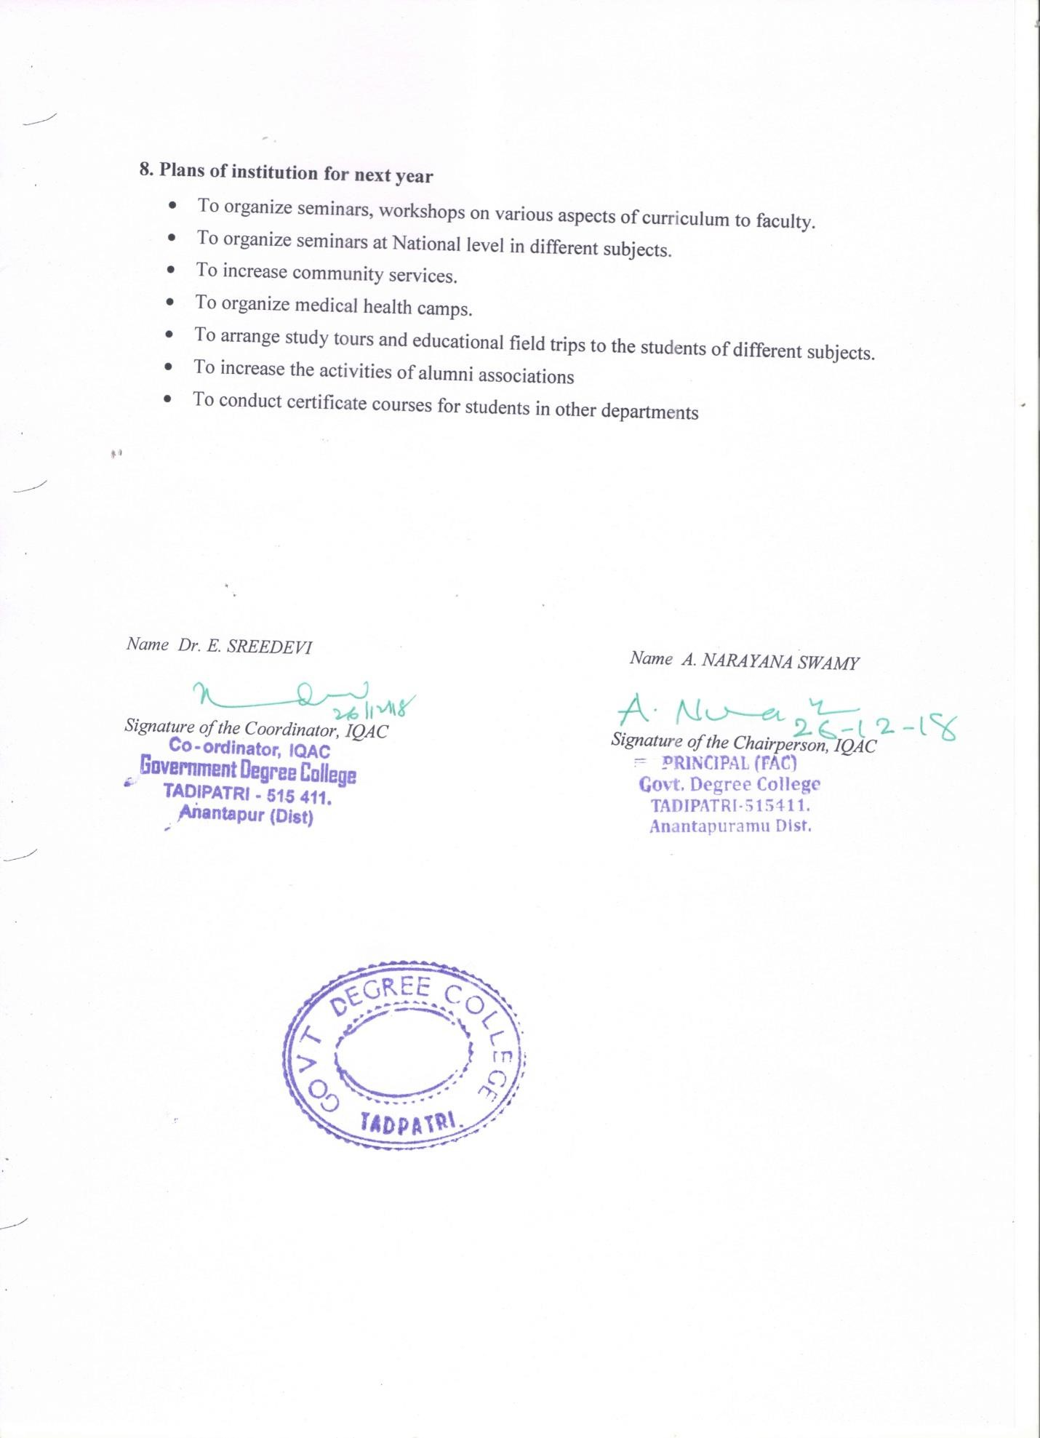

ANNEXURE I
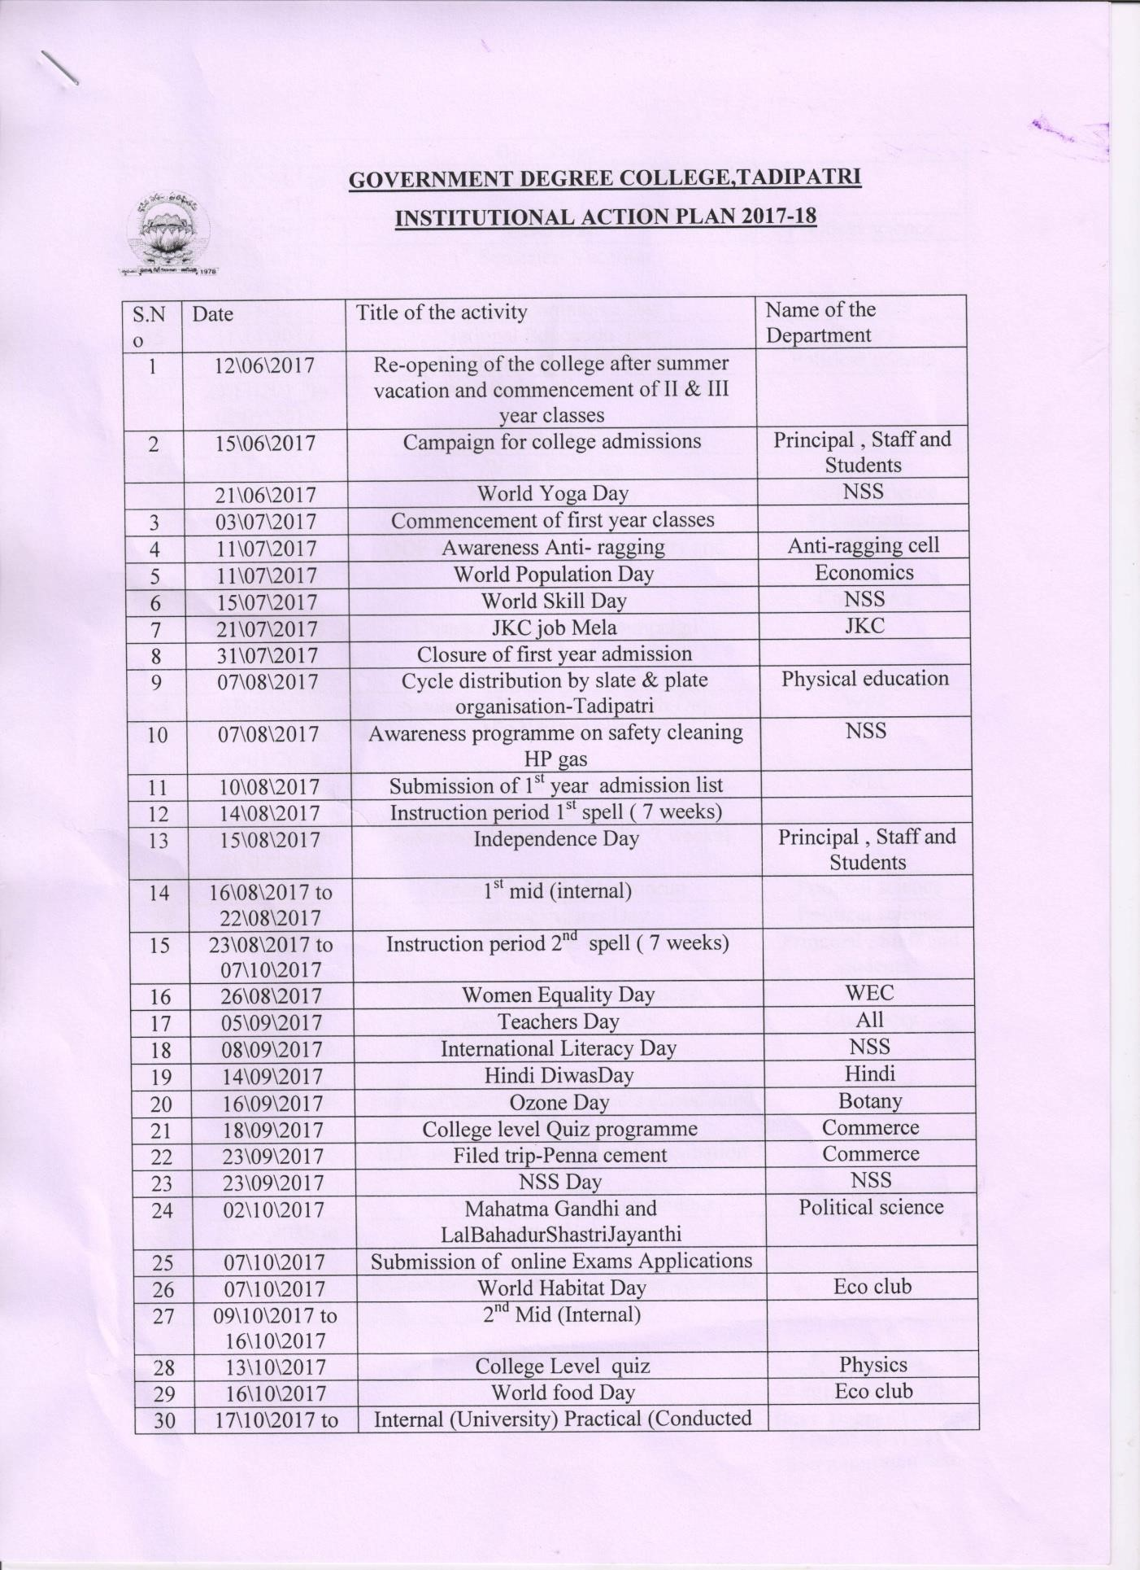
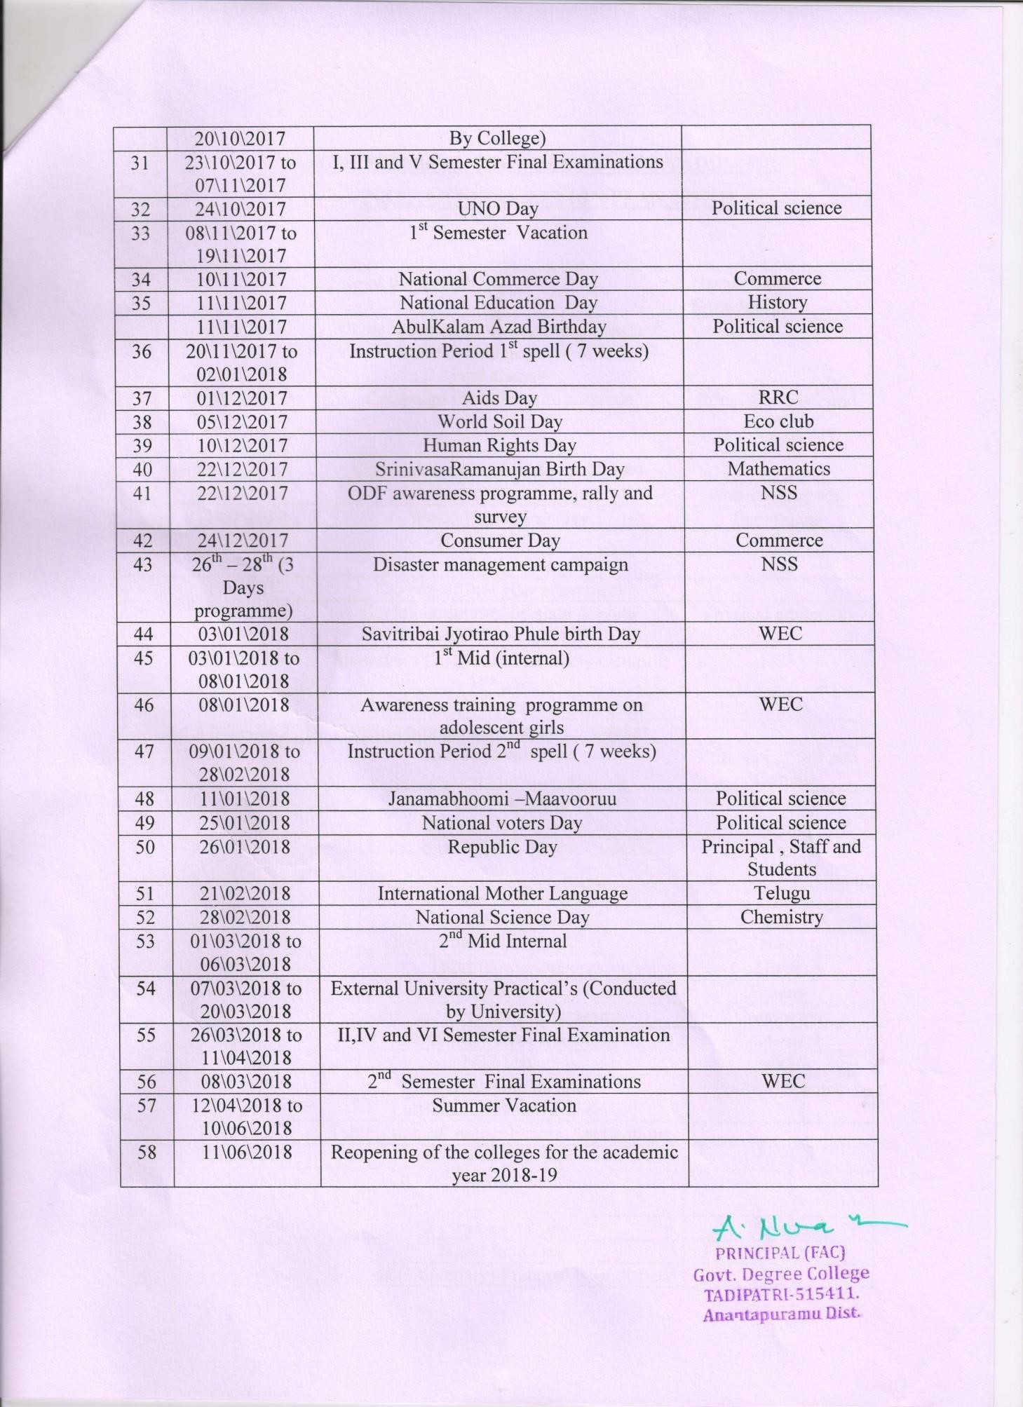

ANNEXURE II
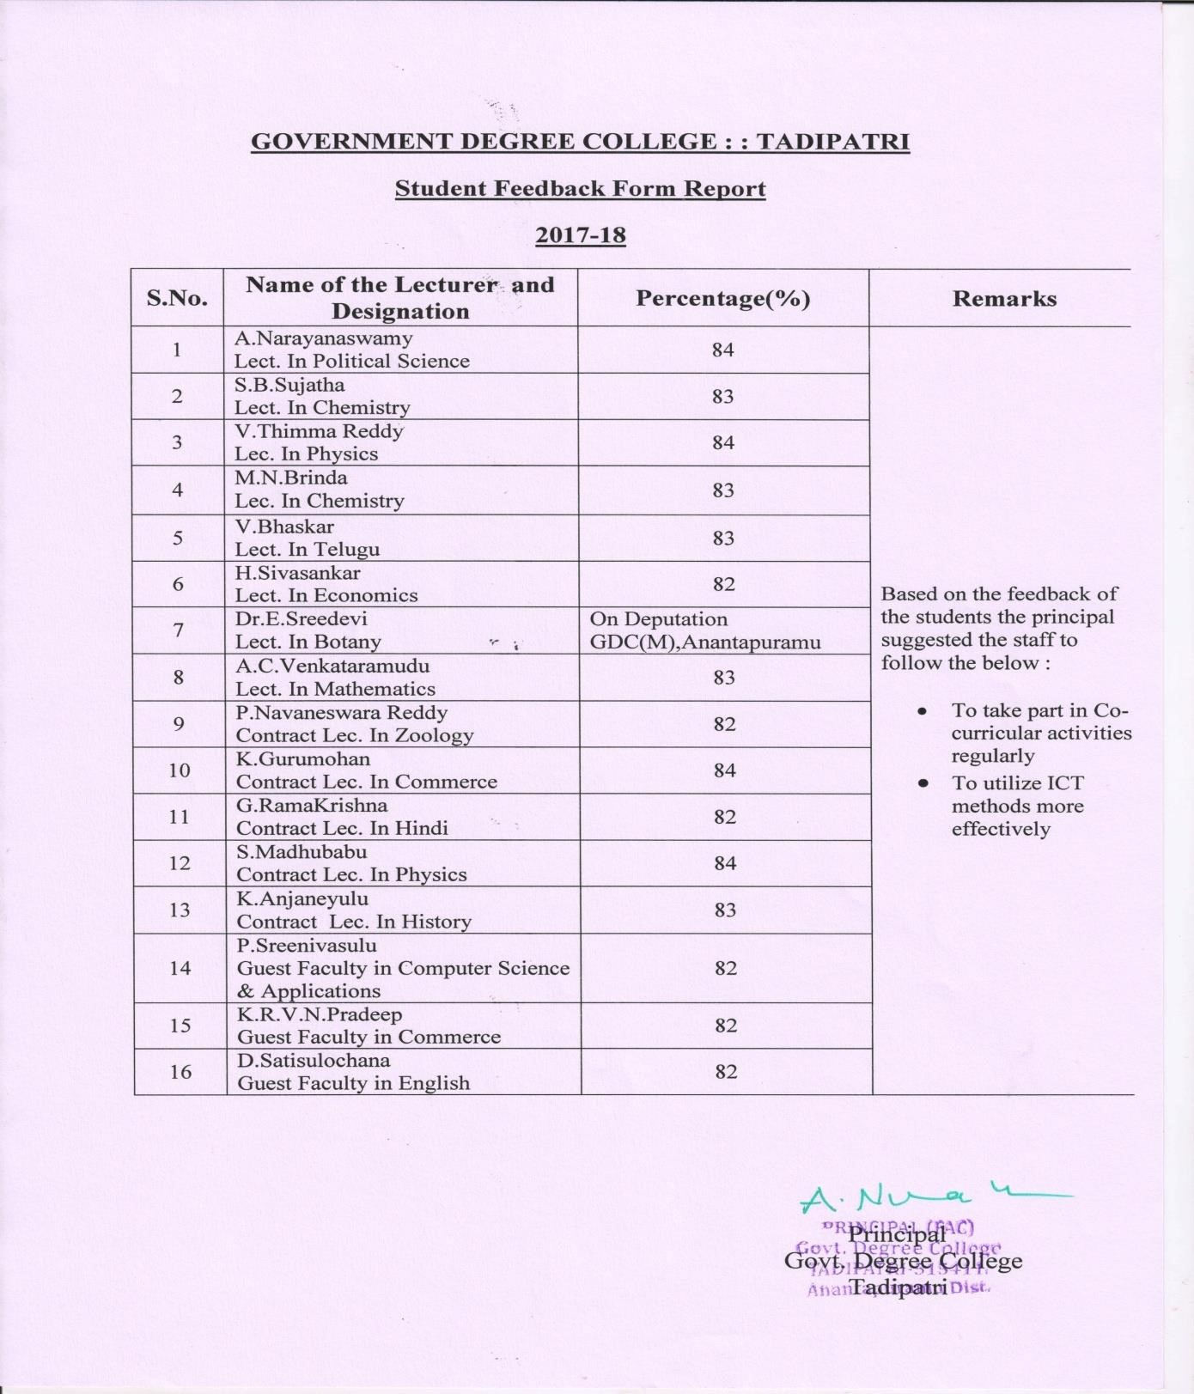
Feed Back Analysis of Students
The students rating on teacher performance is analyzed on the basis of a questionnaire with 21 questions attached below. The rating is divided in four grades viz., A, B, C, D stands for strongly agree, agree, disagree and strongly disagree respectively for each question. The Principal of the College assess the consolidated grades and evaluates the teacher’s performance as per the four point formula prescribed by the CCE, Andhra Pradesh. The feedback analysis report is sent to CCE on regular basis.

III
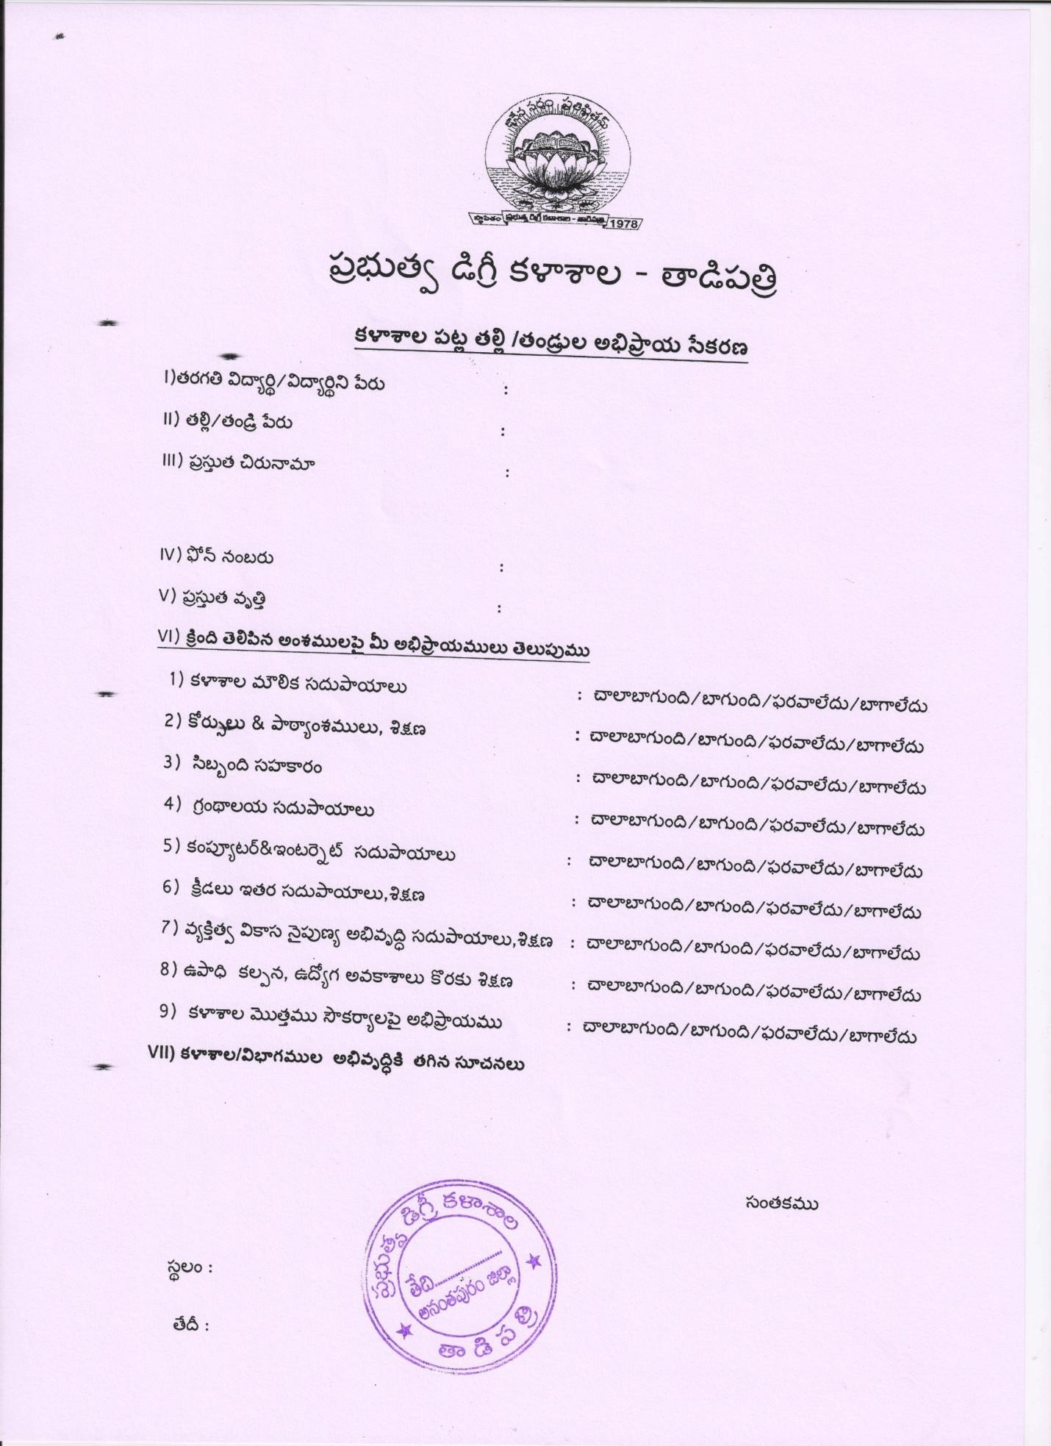

IV
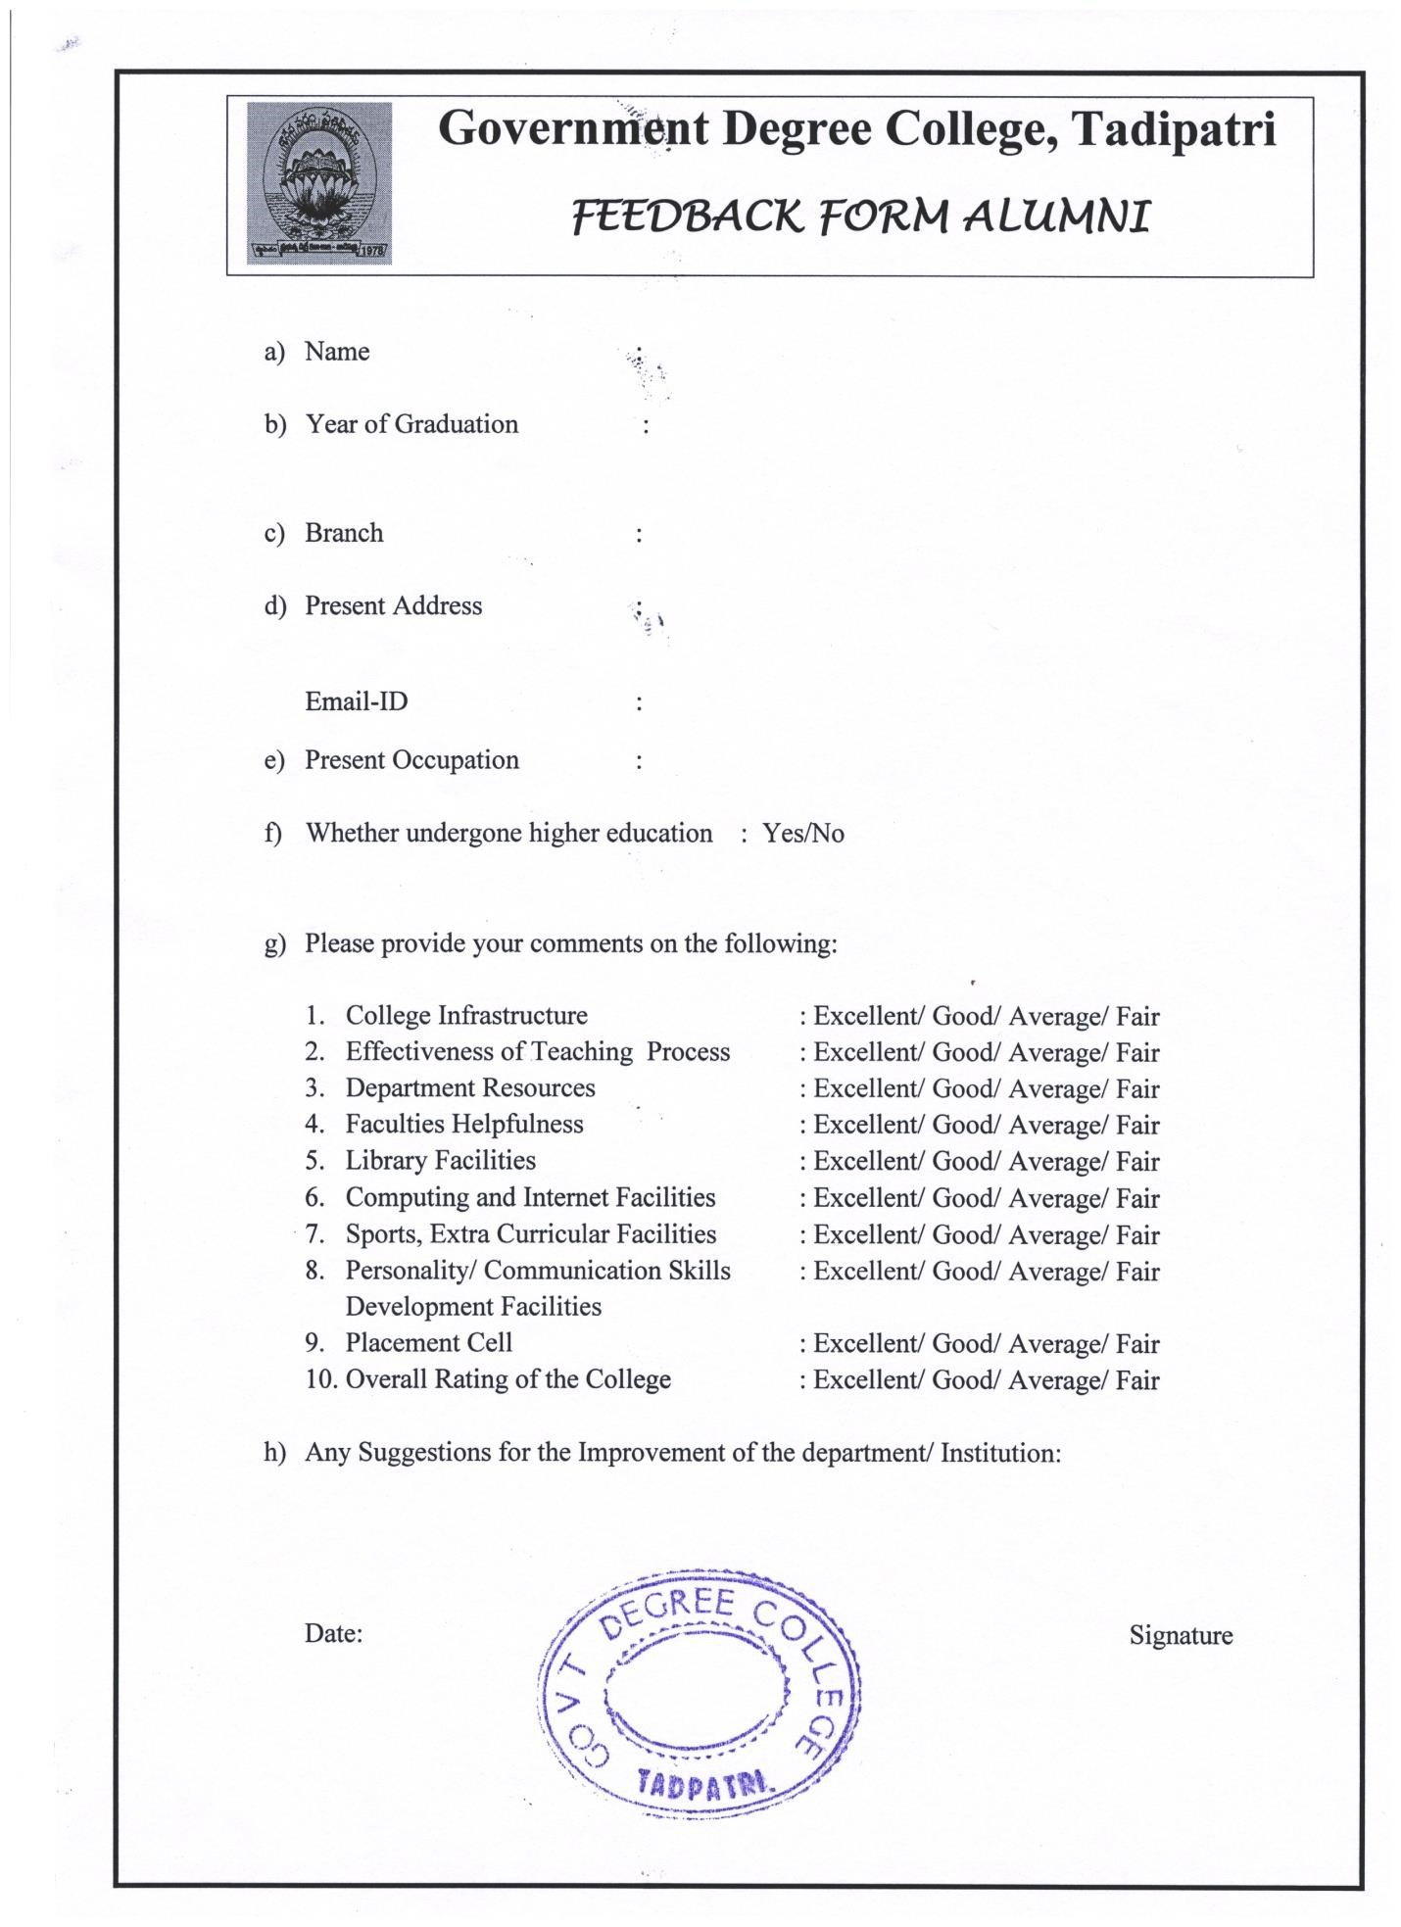

V
- Title of the Practice: Earn while Learn Programme

- Goal/ Objective: The objective of this programme is to support the students through work and integrated learning or engaged learning.

- The context: The concepts of entrepreneurship, economic development, Professional skills etc are to be propagated among the students to build them self sustained in the present scenario. Knowing one or two professional skills which will reap financial benefit helps the students self supportive for their development, higher education etc.

- The Practice:

The departments of Commerce and Computer science have started the MS Office and Excel work to the college and outside offices. The morning hours beyond the College schedule are allotted to implement the practice. The students involved in the practice were benefitted with financial support from the earnings.

- Evidence of success:

The concept of learning while engaged in the work is promoted. Students are benefitted with the fruits of their hard work. At the same time they learnt the skills of task management and effective execution of the plan. The records prepared by the department of commerce and Computer science for the assignments, student projects and other practical examinations at reasonable rate are the best examples for the successful evidence of this practice.

- Problems encountered and Resources required:

No Major problems encountered in the practice. Students are excited to be involved in engaged learning. Such type of programmes can be implemented in more number if financial assistance is provided.

ANNEXURE VI
Best Practice II
Title: Establishment of Ecofriendly attitude and synchronization with the environment
Goal: Conserve or perish has become the slogan of human kind all over the world. College aims towards developing a holistic approach for creating a Eco friendly atmosphere and also follow practices that helps in conservation and protection of environment.
Context: Cleanliness of campus, beautification and pollution free ambience becomes imperative everywhere. The college takes the responsibility by playing a leading role in generating environmental consciousness in the region. The green campus with its large number of trees will help to minimize the harmful effects of pollution from the industry.
The green pasture of the campus helps in soil conservation and is a source of fodder to livestock, which are reared by the cow herds in the vicinity.
Practice: Eco club is established in the college with an aim of conservation and protection of the nature. This club consists of staff and student members, functioning as the organizers of various activities of this club.
Evidence of Success:
Successful conduction of environment audit since 2016-17
Green, tobacco free, plastic free campus explains the success of Program.
Students of all discipline voluntarily participate in all activities related to clean campus and conservation of nature.
Problems Encountered and resources required:
Extreme climatic condition in summer and vacations during that period acts as a limitation too. The Resources required are beyond the capacity and needs to inform among the stakeholders of the college to act as a catalyst in instilling hopefulness for the future.

